Guidance & Equipment Suggestions

**Getting Started**

The below information should give a helping hand in getting started. The back-packing coordinators are available to answer queries or to just discuss any planned trips – best to check first to avoid an application not being accepted.

Please ask a coordinator if you need any assistance completing the application forms or are unsure about your evidence.

The scheme is run by volunteers and therefore there may be a slight delay at times from submitting your application to approval.

A summary of the levels;

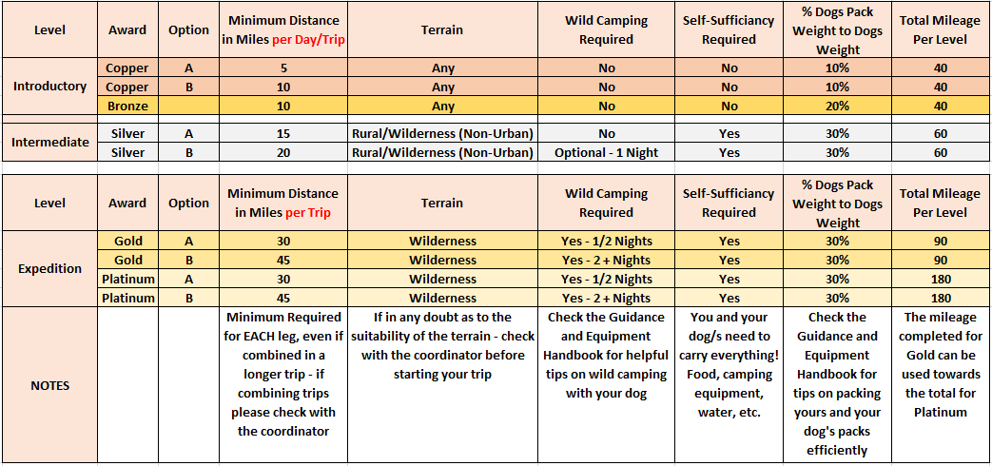

**Basic Training**

Training yourself and your dog to backpack will be different for everyone but the tips below will hopefully help to get you started:

Purchase a good quality backpack of the correct size for your dog and rucksack for yourself

Put the pack on your dog empty at first, use treats every few yards and go for a walk round the block or to the end of the road etc. just don’t go too far. This is all about getting your dog used to wearing the pack. A few tasty treats will confirm to your dog the pack is a good thing!

When you’ve done this a few times and your dog is comfortable with the pack you can add a little weight, for example, 2 small bottles of water/ 1 each side to make sure the weight is evenly distributed. If your dog is slightly unsure then get out the treats and do a few more very short ‘treat’ walks. You can now incorporate the backpack in your normal walks. Let your dog carry the poobags and treats etc!

Two good walks a week with the pack on is a good guide, upping the weight every few weeks. Then when your dog is used to the weight you can build up the distance and so on. There is no rush and this needs to be done slowly to get your dog used to carrying ever increasing weights.

Another point to mention is the width of your dog whilst wearing the pack. They need to get used to the fact that they are wider with the pack on, and so do you for that matter, nothing quite like being pushed in the back of the leg with a laden backpack... ouch!

**Rest stops**

During training and also whilst working through each leg/award, it is very important to remember that your dog needs regular breaks. We all know our dogs love nothing more than to please us and may seem eager to get going again but they still need regular breaks without the backpack on. The more intense the level, the more breaks and length of each individual break is needed.

As a general rule of thumb for every 1.5 hours of walking/hiking it is advisable to rest your dog for at least 15-20 minutes.

**Equipment**

There’s nothing worse than camping out and finding that you’ve left something behind. There’s nothing more dangerous than relying on good weather, carrying the absolute minimum and getting caught out. You need to reach a sensible compromise between the weight carried and the ability to deal with anything that is thrown at you - weather, injury, getting lost, etc.

Whilst we have attached a suggested list of equipment it is down to each participant to use their experience and knowledge to determine what you and your dog will need.

Also consider where you can get drinking water and provisions en-route. This will determine how much you need to carry.

**Suggested Equipment List**

Tent – big enough for you, your dog/s, rucksack and back packs but light in weight

Backpacks (human and dog). Dog packs must be properly balanced under load

Spare strong bags and straps (to attach extra gear/food to your backpack)

A means of safely tethering your dogs overnight. Consider wild and farm animals

Map / route plan / guidance equipment i.e. a compass and map case

Metal hammer - for hitting tent pegs in stony ground

High tensile tent pegs (to resist high winds)

Backpack waterproof liners/dry sacks (dog and human backpacks)

Sleeping bag, liner and mat (essential for insulation from the ground as well as comfort)

Emergency equipment - emergency shelter, space blanket, whistle

Cooking, eating and washing up equipment, portioned dog food (in water-tight bags) and dehydrated human food and energy snacks for both

Hydration supplies (dog and human)

One day’s emergency rations for all team members

Good boots, worn in

Foul weather equipment (even in summer) including waterproofs and an insulated jacket

Toiletries and towel (plus a dog towel - unless you want to share!)

Personal clothing – at least one complete change and a comfortable under layer to sleep in

Head torch

Mobile phone and GPS device – 2 devices to record your trip in case one fails

Waterproof sheet for dog to sleep on and tarpaulin to attach between trees for outside shelter

Dog brush – to remove burs and seeds from under backpack

Sun cream, hat, midge net, insect repellent

Money

Spare batteries and portable/travel phone charger

Pocket knife or similar

Insurance, emergency contact details, i.e. mountain rescue

First aid kit (human and dog) See * below

Suggestions for First Aid Kit *

Plasters, sterile wipes, tick remover, pain killers, antihistamine, vet wrap, sterile eye wash and dog booties (in case of excessive paw wear or injury)

**Wild Camping**

Wild camping is illegal in most areas of the UK. This award scheme is designed for the UK terrain and so we allow the participant to set up camp at registered basic campsites. **AMWA do not accept any responsibility for individuals who wish to wild camp and do so at their own risk.** It is advisable to seek permission of the landowner before making camp.

Overnight campouts – It is highly advisable and sensible to undertake with a group of at least 4 travelling witnesses and/or fellow backpackers.



**Wilderness Areas in the UK**

1 Western Isles

2 Caithness and Sutherland

3 Ross and Cromarty

4 Skye and Lochalsh

5 Inverness

6 Isle of Mull

7 Lochaber and District

8 Grampian and Cairngorm

9 Tayside

10 Trossachs and Crianlarich

11 Lomond and Argyll

12 Isle of Arran

13 Galloway Hills

14 Lowther Hills

15 Scottish Borders

*

20 Cumbria - Lake District

21 Cheviots - Cheviot Hills, Border Forests

22 Durham Dales & High Pennines

(Teesdale, Weardale, Allendale and West to Cross Fell)

23 Yorkshire Dales / Pennines - Langstrothdale to South Pennines

25 North York moors and Cleveland Hills

26 Peak District

27 Snowdonia

28 Mid Wales

29 Beacons

30 Dartmoor

31 Exmoor and Quantock

* For The Isle of Mann and Northern Ireland please contact your backpacking coordinator

For advice on other areas that may be suitable for back packing awards, including outside the UK, please contact the relevant level coordinator or a committee member.

** If you wish to complete a back-packing title outside of the UK, please contact a back-packing coordinator and we will provide the full qualifying criteria. You must be a member of AMWA and your dogs must be registered with the national pedigree registering body **

There is no rush, take your time and enjoy the challenges and most of all the quality time with your dog/s. There is no time limit on how long it takes you to progress through the levels but the table below will help you to keep track of your progress.

|  |  |  |  |  |
| --- | --- | --- | --- | --- |
| **AMWA Backpacking Progress Chart** | | | | |
|  |  |  |  |  |
| Copper | Miles Completed | Date | Location | Total Miles Completed for Level |
| Leg 1 |  |  |  |  |
| Leg 2 |  |  |  |  |
| Leg 3 |  |  |  |  |
| Leg 4 |  |  |  |  |
| Leg 5 |  |  |  |  |
| Leg 6 |  |  |  |  |
| Leg 7 |  |  |  |  |
| Leg 8 |  |  |  |  |
| Total 40 miles |  |  |  |  |
| Bronze |  |  |  |  |
| Leg 1 |  |  |  |  |
| Leg 2 |  |  |  |  |
| Leg 3 |  |  |  |  |
| Leg 4 |  |  |  |  |
| Total 40 miles |  |  |  |  |
| Silver |  |  |  |  |
| Leg 1 |  |  |  |  |
| Leg 2 |  |  |  |  |
| Leg 3 |  |  |  |  |
| Leg 4 |  |  |  |  |
| Total 60 miles |  |  |  |  |
| Gold |  |  |  |  |
| Leg 1 |  |  |  |  |
| Leg 2 |  |  |  |  |
| Leg 3 |  |  |  |  |
| Total 90 miles |  |  |  |  |
| Platinum |  |  |  |  |
| Leg 1 |  |  |  |  |
| Leg 2 |  |  |  |  |
| Leg 3 |  |  |  |  |
| Total 180 miles |  |  |  |  |

**Evidence**

The attached document contains some example evidence – a walk description, map with time and date stamp and an example photo showing a landmark signpost and the back pack weight. The more evidence, details and photos, you can send in, the better.

 Version 1 - 2019/2020