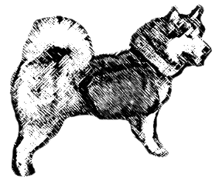
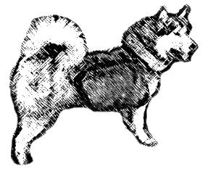
AMWA WORKING PACK DOG APPLICATION FORM

SILVER LEVEL

Page 1 & 2 to be completed once per Level

Owner’s Details
Name: |  |  |  |  | Membership No:
Phone: |  |  | Mobile:
Current address:
Town: |  | County: |  |  |  | Post Code:
Email:

Dogs Info
Registered Name/AMWA Working No:
Pet Name: |  |  |  | KC No:  (IF APL)
Breed: |  |  |  | DOB:

Malamutes Only: Info for ‘ROH’ Programme Sire/Dam Accreditation (Optional)
Sire’s Registered Name: |  |  |  |  |  |  | KC No:  (if known)
Dam’s Registered Name: |  |  |  |  |  |  | KC No:  (if known)

Email:

backpacking@amwa.org.uk

Titled:
‘AMWA Pack Dog Scheme’

Total email attachment max size = approx. 12mb

Post:

Mrs Louise Burgess
6 Broomrigg Crescent
Ainstable
Carlisle
Cumbria
CA4 9QH
Payment:

An invoice will be sent to you once your application has been processed.

NOTE: We will accept either scanned or postal applications but they must include handwritten signatures
Application processing time: 2-4 weeks

Application Check list:

Correct level completed application form
Owner’s name, signature & contact details
Witness signatures & contact details
Sufficient evidence (if unsure please contact the assessor prior to sending)
Veterinary weight verification form
Please make sure all fields of application form are completed
All digital evidence if applicable (route maps) need to be included with your application Pack

Your application cannot be accepted if any of the above are not included!

Fees

£5.00 for first application; £3.00 for each additional application sent at the same time.

Silver level celebration rosette can be ordered at https://www.showrosettes.co.uk/

Silver level sew on badge can be requested with your application and will be posted with your certificate

Page 3 to be completed for each leg per Level

Dog Pet name

Leg + Mileage Completed
Silver Leg number: |  |  | Mileage Completed:

Weight Info
Dog’s weight: |  |  | Dog’s Pack weight at start of Hike:

Witness Info – Verification for Pack Weight +(Start & Finish or Participating)
Starting/Participating Witness - Name:
Phone: |  | Mobile:
Current address:
Town | County |  |  | Post Code:
Finishing Witness – Name:
Phone: |  |  | Mobile
Current address:
Town: | County: |  |  | Post Code:

Signatures:
Signature of applicant: |  |  |  |  | Date:
Signature of Witness: |  |  |  |  | Date:
Signature of second Witness:  (if Applicable) |  |  |  |  | Date:

Event Location Info:
Start Date: |  |  | Time:
Location:
Finish Date: |  |  | Time:
Location:

Please also feel free to add extra info such as a brief review of your trip
we’d love to hear these stories and you never know it may be published in the next edition of the AMWA Newsletter!!

